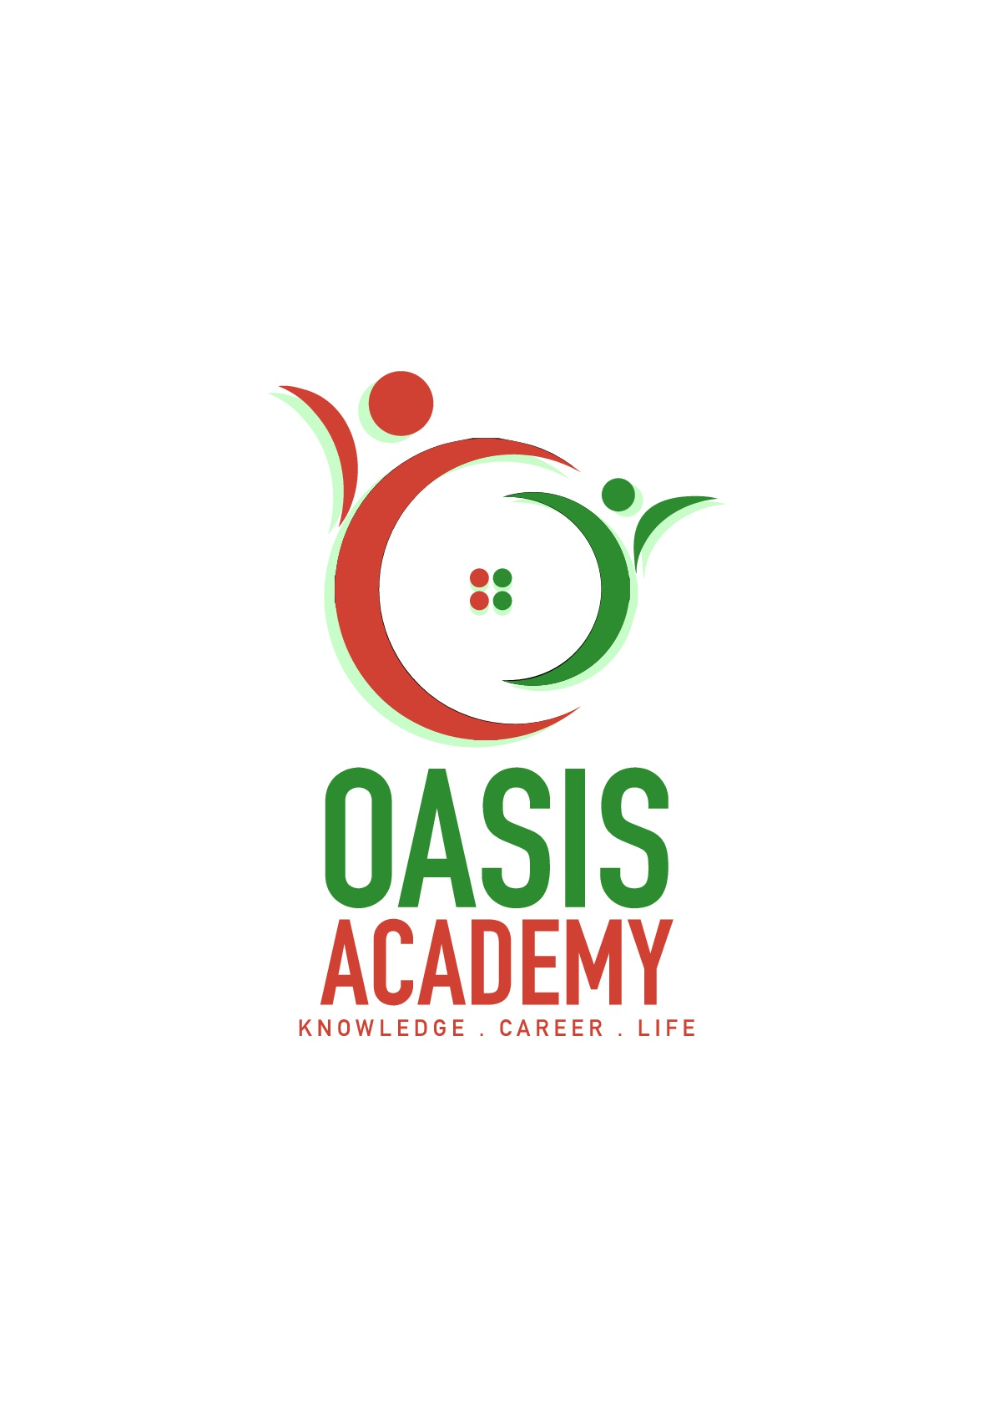

Name: Dineshvaran A/L Mayilvaganam

Login ID: dineshvaran@oasis-portal.com

Course title: Essentials Of Human Resources

Subject Code: BHM01

Submitted date: 05 Jun 2017

**Table of Contents**

|  |  |  |
| --- | --- | --- |
| **No** | **Details** | **Page** |
| 1 | Executive Summary | 2 |
| 2 | Introduction | 3 |
| 3 | Assignment Question |  |
|  | Question 1 | 4 - 6 |
|  | Question 2 | 7 - 10 |
|  | Question 3 | 11 - 13 |
|  | Question 4 | 14 - 17 |
| 4 | Conclusion | 18 |
| 5 | References | 19 |
|  | Appendix | 20 - 22 |

**Executive Summary**

The aim of this assignment is to improve my knowledge about essentials of human resources management within a hospitality management operations which will help me in future. Human Resources is a staff or employee in a organization. First of all, I will introduce four parts which entitled in this task. In first part, I will describe about the major activities and human resources operation in hospitality by giving some definition. Furthermore, in second part, I will explain about the major steps in human resources planning trend in hospitality management. On the other hand, I also will give my opinion about action plan under human resources planning in hotel management. In third part, I will describe and elaborate the functions of management and human resources policies criteria apply in hospitality management. Finally, in fourth part I will briefly explain about organization behavior in executive manner and also will brief about organization behaviors group and structure with deeply. From every part, we can learn about the importance and the roles also system of human resources management at hospitality.

**Introduction**

First of all, we must know meaning and role play of human resources management. Human resources management (HRM) is the governance of an organization’s employees. HRM is sometimes referred to simply as human resources (HR). A company’s human resources department is responsible for creating, implementing and/or overseeing policies governing employee behavior and the behavior of the company toward its employees. Moreover, Human resources are the people who work for the organization; human resource management is really employee management with an emphasis on those employees as assets of the business. The key functions of the Human Resources Management (HRM) team include recruiting people, training them, performance appraisals, motivating employees as well as workplace communication, workplace safety, and much more. As a conclusion, Human Resources Management have own activities, planning trends, policies and organization behavior for creating a best and quality job in Hospitality Department and also other department.

**Assignment Questions**

**Question 1**

**Define the Major Activities and Human Resources Operation in Hospitality Management.**

Human resources management also called as manpower management. Human resource management effectively describes the process of planning and directing the application, development and utilization of human resources in employment. Human resource management (HRM) is the organizational function that deals with issues related to people such as compensation, hiring, performance management, organization development, safety, wellness, benefits, employee motivation, communication, administration, and training. HRM is also a strategic and comprehensive approach to managing people and the workplace culture and environment. The importance of human resources management is select right person for the right job, appraisal of employees, develop the skills of the employee, conductive environment and identify manpower needs. In additional, there are some major activities in human resources management which shown in figure 1.

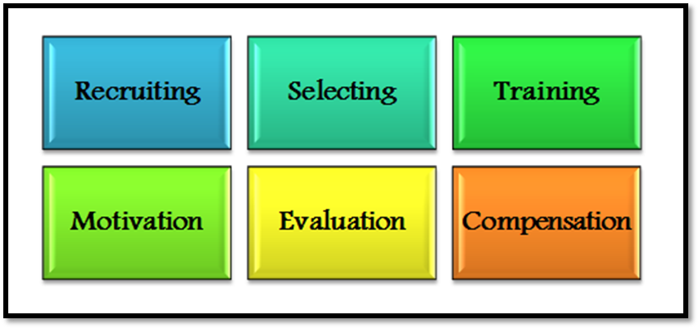

Figure 1.0: Major activities in human resource management

Major activities enables employees to contribute effectively and productively to the overall company direction and the accomplishment of the organization's goals and objectives. This major activities help hospitality management to be develops. Before that, we must understand the meaning of hospitality management. Hospitality management means managing a hotel or the practice of running a hotel. When apply this human resources management’s major activities in the hospitality industry, it presents special challenges, including highly diverse employee backgrounds and roles, an ever-present focus on guest services, and organizational structures that often diverge from generic corporate models. By making such industry-specific concerns the cornerstone of its approach, Human Resources Management in the Hospitality Industry provides the definitive guide to successfully employing people in a hospitality organization.

Explanation of six major activities in human resources management are shown as below:

**Recruiting**

The objective of recruitment is to develop a group of potentially qualified people. Recruiting is a ‘linking function’ joining together those with jobs to fill and those seeking jobs. It is a joining process in that it tries to bring together job seekers and employer with a view to encourages the former to apply for a job with the latter. To this end, the organization must project the position in such a way that job seekers respond. To be cost effective, the recruitment process should attract qualified applicants and provide enough information for non qualified persons to self select themselves out.

**Selecting**

Selection is a screening process. It is the process of picking individuals who have relevant qualifications to fill jobs in an organization. The basic purpose is to choose the individuals who can most successfully perform the job from the pool of qualified candidates. Selection starts after the recruitment process is over and job application has been received.

**Training**

Training involves the change of skills, knowledge, attitudes, or behavior of employees. Although training is similar to development in the methods used to affect learning, they differ in time frames. Training is more present-day oriented, its focus is on individual’ current jobs, enhancing hose specific skills and abilities to immediately perform their jobs. Training is job specific and is designed to make employees more effective in their current job. Employee development, on the other hand, generally focuses on future jobs in the organization.

**Motivation**

Motivating employees to perform up their potential is the key to maintaining a productive, successful business. There are four ways which can motivate employees. First of all, interact. It means talk to employees regularly. Recognition and appreciation is a second way. Pay employees for what they are worth and they will be happy to work is third way. Fourth way is new challenges, which give employees new and interesting challenges to keep them stimulated and learning.

**Evaluation**

After an employee has worked on a job for a period of time, his performance should be evaluated. Performance evaluation is the process of deciding how an employee does his job or to identify employees who are performing well and those who aren’t. Performance here refers to the degree of accomplishment of the tasks that make up an employee’s job. It indicates how well an individual is fulfilling the job requirements.

**Compensation**

Compensation and benefits policies and procedures begin with developing compensation strategy. Compensation strategy should be documented plans with functional steps for implementation. There are three basics in compensation: commission, bonus and stock options. Commission is a compensation based on fixed formula for sales. Bonus is periodical compensation based on the store’s performance during the period. Stock options means employees are encourage to buy shares of their company at discounted prices.

**Question 2**

**Describe in brief on Human Resources Planning and Planning Trend in Hospitality.**

**Explain about what is your understanding on Action Plan Human Resources Planning in Hotel Industry.**

Human resource planning or HRP is the ongoing continuous process of systematic planning to achieve optimum use of an organization's most valuable asset in human resources. The objective of human resource planning is to ensure the best fit between employees and jobs while avoiding manpower shortages or surpluses. Systematic analysis of human resources need in order to ensure that the which ensure that the right number and right kind of people are available at the right time, at the right place to do the right job and to do the job right Human Resource Planning in Hotel Industry.

The four key steps of the human resources planning process are:

1. analyzing present labor supply
2. forecasting labor demand
3. balancing projected labor demand with supply
4. supporting organizational goals.

The process of human resources is a continuous process which starts with identification of human resources objectives, move through analysis of manpower resources and ends at appraisal of human resources planning.

Importance of Human Resources Planning organizations use to meet future challenges, cut costs, and achieve greater effectiveness by create a talent pool, prepare people for future, cope with organizational changes, cut costs and help succession planning Human Resource planning in hotel industry.

Human Resources Planning trend in hotel industry such as:

1. Outsourcing

Is creating talent pool to the new hires ad new candidate are by submitting new applicant’s information according the needs of organization. The final selection will made by organization. Furthermore, they have to pay service charge based on works.

1. Internship

Internship called as graduate intake programe. It is usually will done by student or undergraduate who study for months or year. The purpose is to gain experience based on knowledge with peer in the related industry of their field.

1. Talent pool

Create database by using information technology to find candidate profile, interested in working in the organization. Talent pool also act as mini recruitments agency which use to identify quality candidates for the future. The information will kept as privacy or secret.

1. Poaching and raiding

“Buying talent” rather than developing it by offering attractive packages and other terms and conditions, better than the current employer of the candidate. They also giving unethical practice for employee with different skills. It has become a challenge for human resource managers to face and tackle poaching, as it weakens the competitive strength of the firm.

1. E-recruitment

Human Resources Planning trend in hotel industry e-recruitment is advertising the vacancies through website. For example, receiving resume from e-mail. Interview process also will happen through support of information technology by recruitment of right type of people and low cost human resource planning in hotel industry. Moreover, by online recruitment can advertise about the vacancy in website such as Facebook, Instagram, indeed and many more.

Major steps in human resources planning are as shown in figure 1.1. This steps must be taken to achieve goals in hospitality department. The aim is to clarify the type of resource are required to the reach the goal.

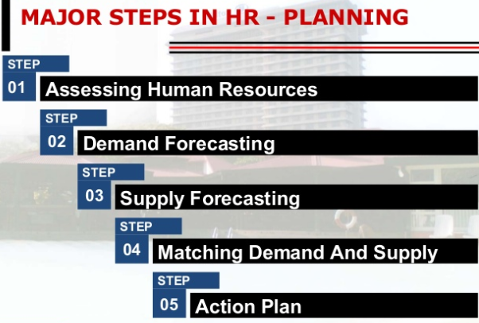

Figure 1.1 : Major steps in HR - Planning

Explanation for major steps in human resources planning are show in below.

1. Assessing Human resource

The assessment of HR begins with environmental analysis. After the analysis of external and internal (objectives, resources and structure) forces of the organization, it will be easier for HR manager to find out the internal strengths as well as weakness of the organization in one hand and opportunities and threats on the other. Moreover, it includes an inventory of the workers and skills already available within the organization and a comprehensive job analysis (Figureb1.2).

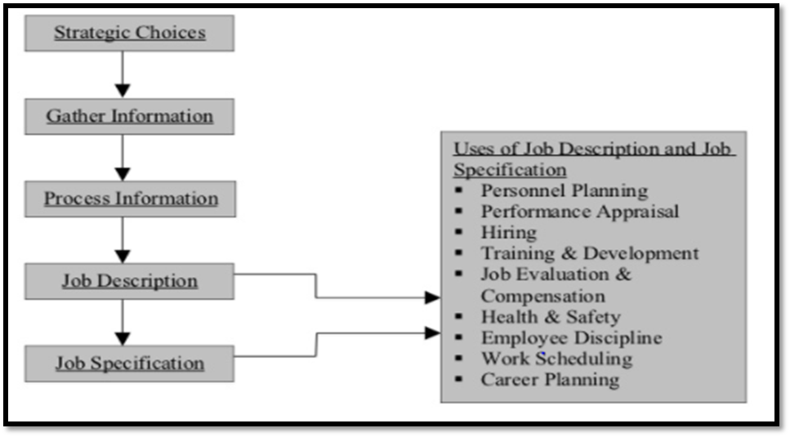

Figure 1.2: Process of job analysis

1. Demand Forecasting

HR forecasting is the process of estimating demand for and supply of HR in an organization. Demand forecasting is a process of determining future needs for HR in terms of quantity and quality. It is done to meet the future personnel requirements of the organization to achieve the desired level of output. It can be estimated with the help of the organization's current human resource situation and analysis of organizational plans and procedures. It will be necessary to perform a year-by-year analysis for every significant level and type.

1. Supply Forecasting

Supply is another side of human resource assessment. It is concerned with the estimation of supply of manpower given the analysis of current resource and future availability of human resource in the organization. It estimates the future sources of HR that are likely to be available from within an outside the organization. Internal source includes promotion, transfer, job enlargement and enrichment, whereas external source includes recruitment of fresh candidates who are capable of performing well in the organization.

1. Matching demand and supply

It is another step of human resource planning. It is concerned with bringing the forecast of future demand and supply of HR. The matching process refers to bring demand and supply in an equilibrium position so that shortages and over staffing position will be solved. In case of shortages an organization has to hire more required number of employees. Conversely, in the case of over staffing it has to reduce the level of existing employment. Hence, it is concluded that this matching process gives knowledge about requirements and sources of HR.

1. Action Plan

It is the last phase of human resource planning which is concerned with surplus and shortages of human resource. Under it, the HR plan is executed through the designation of different HR activities. The major activities which are required to execute the HR plan are recruitment, selection, placement, training and development, socialization etc. Finally, this step is followed by control and evaluation of performance of HR to check whether the HR planning matches the HR objectives and policies. This action plan should be updated according to change in time and conditions.

**Question 3**

**Brief about Human Resources Functions and Human Resources Policies.**

**Describe the Function of Management and How the policy applies accordingly in Hospitality Management.**

The goal of a human resource manager is to strengthen the employer-employee relationship. This goal is supported by a variety of functions within the human resources department and throughout the organization. In a small business, the human resource manager may have a great degree of latitude, as well as the time to devote to employee interaction with a small workforce. Both of these are key elements of an effective human resources leader, although there are some accomplish a number of functions to achieve this goal. Such as:

1. Training and development

This function of human resource management helps the employees to acquire skills and knowledge to perform their jobs effectively. Training and development programs are organized for both new and existing employees. Employees are prepared for higher level responsibilities through training and development.

1. Compliance

HR capacities are normally understaffed and exhausted. As noted, resistance can be the reason for money related and reputational dangers for associations. Leading booked HR consistence reviews tought to be a piece of an association's general procedure to maintain a strategic distance from any legitimate liabilities.

1. Safety

Working condition security is an essential variable. Under the Word related Thriving and Flourishing Presentation of 1970, associations have a promise to give a secured workplace to delegates. One of the standard parts of HR is to bolster work environment security arranging and keep up officially summoned logs for work space naughtiness and misfortune determining. In like way, HR thriving and danger authorities a great part of the time work by and by with HR benefits specialists to deal with the affiliation's laborers pay issues.

1. Contracting

The achievement of scouts and work authorities by and large is measured by the measure of positions they fill and the time it takes to fill those positions. Selection specialists who work in-house - rather than affiliations that give picking and staffing associations - acknowledge a key part in working up the business' workforce. They propel work postings, source hopefuls, screen candidates, organize preparatory get-togethers and orchestrate using tries with executives in charge of settling on the last choice of contenders.

1. Labor relations

In a unionized workplace, the master and work relations parts of HR might be cemented and overseen by one master or be all around autonomous points of confinement managed by two HR specialists with particular strength in each range. Assign relations are the HR get ready worried with reinforcing the business master relationship through measuring work fulfillment, specialist engagement and settling working environment fight. Work relations points of confinement may merge making association reaction to union managing battles, engineering absolute overseeing authentications and rendering understandings of worker's affiliation contract issues. In an organization tasks are allocated among its members, relationships are identified, and activities are integrated towards a common objective. Relationships are established among the employees so that they can collectively contribute to the attainment of organization goal.

1. Recruitment and Selection

Recruitment of candidates is the function preceding the selection, which brings the pool of prospective candidates for the organization so that the management can select the right candidate from this pool.

Human resources policies are continuing guidelines on the approach an organization intends to adopt in managing its people. They represent specific guidelines to HR managers on various matters concerning employment and state the intent of the organization on different aspects of Human Resource management such as recruitment, promotion, compensation, training, selections etc. They therefore serve as a reference point when human resources management practices are being developed or when decisions are being made about an organization's workforce. A good HR policy provides generalized guidance on the approach adopted by the organization, and therefore its employees, concerning various aspects of employment. A procedure spells out precisely what action should be taken in line with the policies. Each organization has a different set of circumstances and so develops an individual set of human resource policies. The locations an organization operates in will also dictate the content of their policies.

In actuality, policies and procedures serve a number of purposes:

1. They provide clear communication between the organization and their employees regarding their condition of employment.
2. They form a basis for treating all employees fairly and equally.
3. They are a set of guidelines for supervisors and managers.
4. They create a basis for developing the employee handbook.
5. They establish a basis for regularly reviewing possible changes affecting employees.
6. They form a context for supervisor training programs and employee orientation programs.

The function of management in hotel industry based on policies gave many advantage for hospitality management. First of all, it helps managers at various levels of decision making to make decisions without consulting their superiors. Subordinates are more willing to accept responsibility because policies indicate what is expected of them and they can quote a written policy to justify their actions. Furthermore, it ensures long term welfare of employees and makes for a good employer-employee relationship as favoritism and discrimination are reduced. Moreover, well-established policies ensure uniform and consistent treatment of all employees throughout the organization. It lays down the guidelines pursued in the organization and thereby minimizes the personal bias of managers. It also ensures prompt action for taking decisions because the policies serve as standards to be followed. They prevent the wastage of time and energy involved in repeated analyses for solving problems of a similar nature. It establishes consistency in the application of the policies over a period of time so that each one in the organization gets a fair and just treatment. Employees know what action to expect in circumstances covered by the policies. Policies set patterns of behavior and permit employees to work more confidently.

  In order to develop the policies regarding the employees in the organization, the HR manager needs to be more proactive, since working in the international business environment needs to incorporate different cultures, as it has been discussed above in the report. Moreover the HR manager needs to deal with different laws and regulations depending upon the country or the countries they are working in. this mean that the HR manager needs to develop policies in which every aspect is being taken care off so that the management is able to have better relations with the employees. These policies must incorporate the different operational issues like sexual harassments and other problems that the employees are facing in their duties.

**Question 4**

**Explain in details about Organizational Behavior in Hospitality and brief on Groups and Structure in Organization.**

What is Organizational Behavior?

1. **Organization:**It is a group of people who are collected to work for a common goal with collective efforts. Organization works through two concepts which is coordination and delegation among its group members. Delegation is necessary to allocate group members with equal work according to their capability and coordination is required to achieve organizational goal with precision.
2. **Behavior:**It is a verbal or physical response shown by a person as a consequence of the impact of a staff surroundings. Individual Behavior varies in accordance with their mental reactivity to particular circumstances because of their deeply imbibed morals and value system.
3. **Organizational Behavior:**Organizational Behavior is the observation of individual or group Behavior in response to the other individuals or group as a whole. It studies Behavior of people or group to know their attitude towards particular circumstances.
4. **Fundamental Aspects Of Organizational Behavior:**
   * **People:**This element is the soul of the Organization because people work to achieve the target of Organization and Organization works to fulfill the needs of individual or group of individuals. The word ‘people’ can be anyone who is working inside the Organization, like employees or any external person like supplier, customer, auditor, or any government official.
   * **Structure:**It is the body of the Organization which is to be taken care of to bring coordination between different levels of Organization, because Organization does not work aloof and is dependent on people which again work on the concept of division of labor. So, there is always a hierarchy in Organization which if not properly dealt with can mess the system because of nil scrutiny and flow of control.
   * **Technology:**Organizations work on technologies to help people in efficiently doing their work. Same technology does not apply to each Organization but different Organizations demand different technologies for their different line of businesses example bank needs mediating technology which connects customers and bankers, Manufacturing companies need long linked technology because of their assembly line process, and hospitals work on intensive technology because of their responsibility to provide specialized services in terms of doctors and medical equipments.
   * **Environment:**Organizations are influenced by the environment in which they work, at a substantial level. Environment is important to Organizations because of supply and demand comes from this environment. Human resource, competitors, government agencies, unions, and political parties come from environment in which Organization is surviving. The Organizations have to follow rules and regulations fostered by this environment.

Importance of Organizational behavior:

1. It builds better relationship by achieving people’s, organizational, and social objectives.
2. It covers a wide array of human resource like behavior, training and development, change management, leadership and teams.
3. It brings coordination which is the essence of management.
4. It improves good will of the organization.
5. It helps to achieve objectives quickly.
6. It makes optimum utilization of resources.
7. It facilitates motivation.
8. It leads to higher efficiency.
9. It improves relations in the organization.
10. It is multidisciplinary, in the sense that applies different techniques, methods, and theories to evaluate the performances.

The following are the issued faced by the human resources in organizational behavior.

1. Work force Diversity
2. Employee Privacy:
3. Employee Rights:
4. Unionism:
5. Changed Employee Expectations:

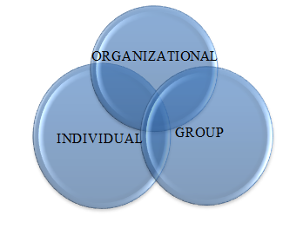

Figure 1.3: Organizational Behavior Chart

**Organizational Structure**

The typically hierarchical arrangement of lines of authority, communications, rights and duties of an organization. Organizational structure determines how the roles, power and responsibilities are assigned, controlled, and coordinated, and how information flows between the different levels of management.

# A structure depends on the organization's objectives and strategy. In a centralized structure, the top layer of management has most of the decision making power and has tight control over departments and divisions. In a decentralized structure, the decision making power is distributed and the departments and divisions may have different degrees of independence.

# Six Elements of Organizational Structure

# C:\Users\ASUSPC\Desktop\Capture.JPG

# Figure 1.4: Six elements of organizational structure

# Work Specialization

# Other organizations have employees specialize in individual tasks so that the workers become highly proficient in their specialized area. Work specialization, sometimes called a division of labour, refers to the degree to which an organization divides individual tasks into separate jobs.

# Departmentalization

# is an aspect of organizational design that includes the subdivision of a business into units based on their function or other criteria. Most companies, including restaurants, are likely to use two or more types of departmentalization simultaneously.

# Chain of command

# In an organizational structure, “chain of command” refers to a company's hierarchy of reporting relationships from the bottom to the top of an organization, who must answer to whom. The chain of command not only establishes accountability, it lays out a company’s lines of authority and decision-making power. A proper chain of command ensures that every task, job position and department has one person assuming responsibility for performance.

# Span of control

# The number of subordinates that a manager or supervisor can directly control. This number varies with the type of work complex, variable work reduces it to six, whereas routine, fixed work increases it to twenty or more.

# Centralization/decentralization

# The process of transferring and assigning decision-making authority to lower levels of an organizational hierarchy. In a decentralize organization, the decision-making has been moved to lower levels or tiers of the organization, such as divisions, branches, departments or subsidiaries.

# Formalization

# Formalization in organizational structure is a process in which managers specify, procedures, rules and responsibilities for the individual employees, organizational units, groups, teams and the organization as a whole, which leads to the development of processes, relationships, and operating procedures.

One of the main important elements that has noted is that the consumer behaviour is hospitality industry is changing with significant rates. As compared to the last couple of decades the behaviours of the customers have been changed and the main reason behind this change is the mode of globalization. As discussed in the above report that the since the business world has entered into globalization mode, the hospitality industry has managed to grow faster than ever before because the visitors now find this easy to move from one region to another easily and with many facilities (Mondy, 2008).

And since the customers have now visited many places across the world, the roles of human resource personnel have become more critical. Today, the human resource personnel have to ensure that they design the organizational policies and regulations according to the consumer behaviour. But the changing behaviours of the consumers are restricting the human resource personnel to do so. Many of the companies and their HR departments are now planning and redesigning their strategies to ensure that the consumer behaviours are properly understood. As compared to the past few years, the HR personnel in hospitality industry have become more responsible to understand the needs and requirements of the customers and act accordingly.

**Conclusion**

From this task, I have learned about essential human resources. I also get a clear picture on human resource management and how it’s applied in hospitality management. Human resources department is responsible for creating, implementing and/or overseeing policies governing employee behavior and the behavior of the company toward its employees. The importance of major activities in human resources management easy to select right person for the right job, appraisal of employees, develop the skills of the employee, conductive environment and identify manpower needs. Major activities enables employees to contribute effectively and productively to the overall company direction and the accomplishment of the organization's goals and objectives. Moreover, I also can identifying human resource planning or HRP which is the ongoing continuous process of systematic planning to achieve optimum use of an organization's most valuable asset in human resources based on some steps use in HR planning. Furthermore, I get a better understanding about function of human resources by evaluating policies. It help maintain individual development, working relationship among the peer and effective modeling of human resource as contracted with physical resource. I have learned about organizational behavior in hospitality and also structure in groups and structure in organization. As overall, I can identify the important of human resource in hospitality management. As a business student, I am lucky to do this assignment because it give me many input and knowledge about human resource management based on hospitality department.

**References**

Mondy R. W. (2008). *Human Resources Management 3rd Edition*. Pearson Education: India.

<https://www.shsconferences.org/articles/shsconf/pdf/2014/09/shsconf_4ictr2014_01076.pdf> “Human Resource Management Practice Tourism and Hotel Industry”.

<https://www.slideshare.net/rajasshrie1/chapter-1-ob-38248150>

“Introduction To Organizational Behavior”.

<http://smallbusiness.chron.com/key-human-resource-management-policies-procedures-60802.html> “Key Human Resource Management Policies & Procedures”.

<https://www.slideshare.net/ZeinulHaleem2/human-resource-management-in-hotel-industry> “ Human Resources Planning”.

<https://www.slideshare.net/CrystialParrilla/introduction-to-human-resource-management-in-hospitality-industry> “Human Resources Management”.

<https://www.slideshare.net/manishray/1basicconceptsofob> “Basic Concepts of Organizational Behavior”

<https://en.wikipedia.org/wiki/Human_resource_policies> “Human Resources Policies”

<https://writepass.com/journal/2012/11/human-resource-management/> “Human Resources Management”

**Appendix**



Figure 1.0: Major activities in human resource management



Figure 1.1 : Major steps in HR - Planning

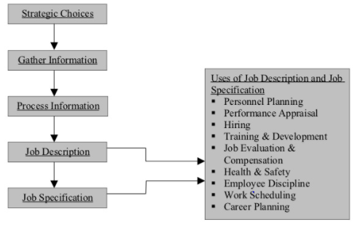

Figure 1.2: Process of job analysis



Figure 1.3: Organizational Behavior Chart

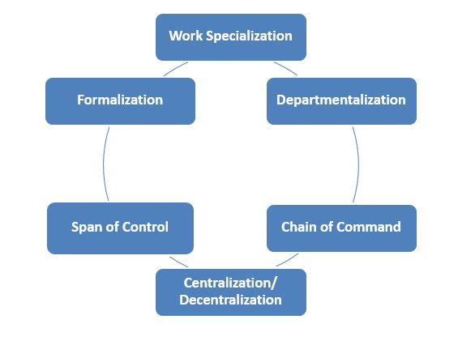

# Figure 1.4: Six elements of organizational structure

THE END